**Operating Systems Lab**

**Fall 2024**

**Lab Task 06:**

**Understanding RPM/YUM Package Management**



**Lab Instructor:**

**Kausar Nasreen Khattak**

**Bachelor of Computer Science – 5th Semester**

**Subject: Operating system**

**Submitted to: MS. Kausar**

**Submitted by: Faareha Raza**

**Sap ID: 47431**

**Email:**

**kausar.nasreen@riphah.edu.pk**

**Lab Task**

**Q1:** Explain the process of compiling a C program in Linux. What command is used to compile the program?

**Process**:

1. Write the C program using a text editor and save it with a .c extension.
2. Use the GCC command to compile the source file into an executable.

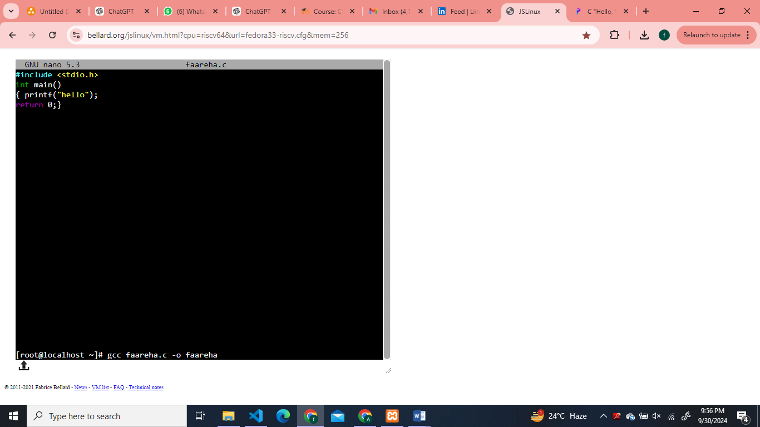

**Q2:** What is the purpose of the -o option in the gcc command? Provide an example.

The -o option in gcc specifies the name of the output file. Without it, the compiled output .



**Q3:** What is the difference between g++ and gcc? When would you use each?

• **gcc**: Primarily used for compiling C programs.

• **g++**: Used for compiling C++ programs. It automatically links the necessary C++ libraries.

• **When to use**:

* Use gcc for C programs.
* Use g++ for C++ programs or if your project involves C++ libraries.

**Q4:** How do you compile and run a C++ program from the terminal? Provide the necessary commands.

**g++ program.cpp -o program**

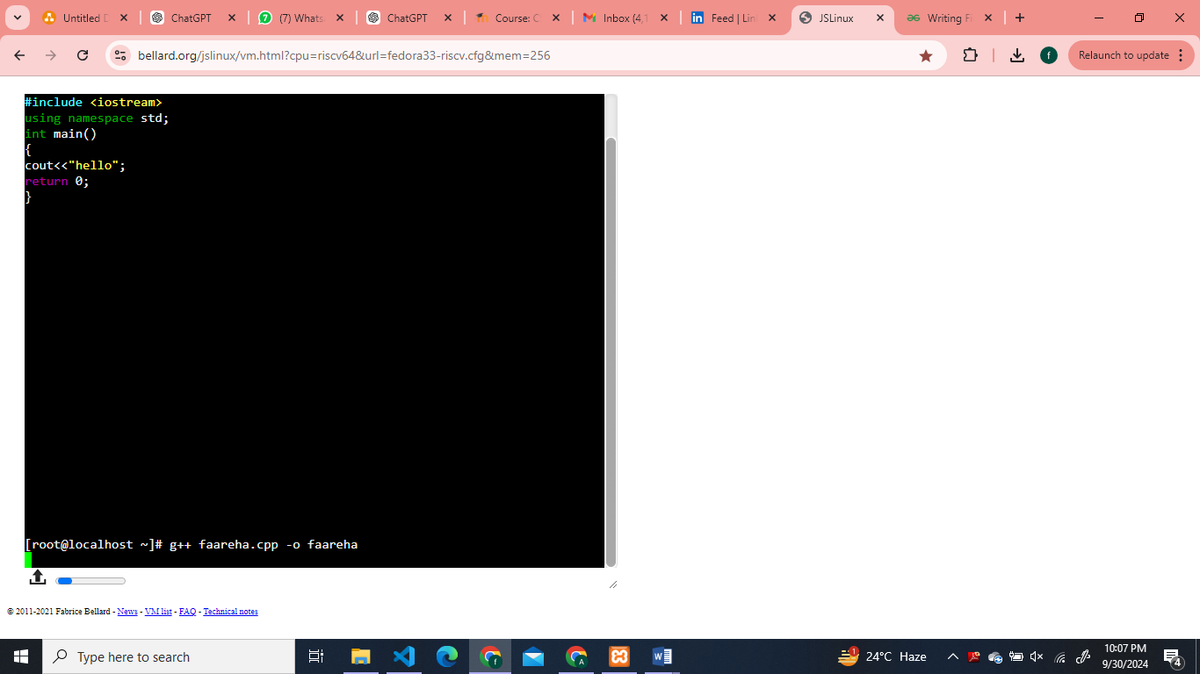

**Q5:** What are templates in C++ in Linux? Write a simple example of a function template.

**Templates**: C++ templates allow functions or classes to operate with generic types, providing a way to create flexible, reusable code.

**Example:**

#include <iostream>

using namespace std;

template <typename T>

T add(T a, T b) {

return a + b;

}

int main() {

cout << add(3, 4) << endl; // Calls with int

cout << add(5.5, 2.2) << endl; // Calls with double

return 0;

}

**Q6:** Discuss the significance of file extensions in C programming. Why should source files be saved with .c or .cpp extensions?

• **Significance**: File extensions indicate the type of source code and help the compiler determine how to process the file:

* .c: Indicates a C source file.
* .cpp: Indicates a C++ source file.

• **Importance**: Compilers like gcc and g++ use file extensions to apply the correct compilation process for the programming language.

**Q7:** What are the common errors that can occur when compiling C programs, and how can they be resolved?

**Common errors**:

1. **Syntax errors**: Caused by incorrect syntax. Resolve by correcting the syntax in your source file.
2. **Linking errors**: Occur when the compiler can't find functions you're using. Ensure you include the correct libraries and link any required files.

**Q8:** Explain how you can manage permissions for an executable file in Linux. What command is used for this purpose?

**Managing permissions**: To execute a file, you need executable permissions.

**chmod +x filename**

**Q9:** What is a tarball, and what advantages does it offer for distributing software on Linux? Discuss the limitations of using tarballs for software installation and management.

**Tarball**: A tarball is a compressed archive of files

* **Advantages**: Allows easy distribution of multiple files in one archive, compresses files to save space.
* **Limitations**:
  + No dependency management.

**Q10:** Explain the purpose of the RPM package format and how it addresses the shortcomings of tarballs.

**RPM** (Red Hat Package Manager) is a package format that provides:

* Automatic dependency checking.
* Easier installation and uninstallation of software.
* Management of package versions, improving system consistency.